

**CYPRUS INTERNATIONAL UNIVERSITY**

**FACULTY OF ENGINEERING**

**COMPUTER & INFORMATION SYSTEMS ENGINEERING**

**ISYE300**

**INFORMATION REPORT ON SUMMER TRAINING COURSE**

**02/10/2020**

STUDENT

NAME : BARIŞ

SURNAME : KARAPELİT

NUMBER : 21707346

TRAINING PLACE

NAME : INVACO

ADDRESS : Teknopark-Yıldız Teknik Üniversitesi, Çifte Havuzlar Mah. Eski Londra Asfaltı Cad. A1 Blok No:151/1C 1B27 Esenler/ISTANBUL

TRAINING DATE : 01/08/2020 – 14/09/2020

PHONE NO : +90 541 925 7074

WEB ADDRESS : http://www.invaco.net/

Table of Contents

1 INTRODUCTION 4

2 INFORMATION ABOUT THE COMPANY 5

2.1 Aim And Establishment Of The Company 5

2.1.1 Establishment Of The Company 5

2.1.2 Position Of Company In Turkey 6

2.1.3 Types Of Services Provided 6

2.1.3.1 Digital Transformation and Internet Of Things Projects 6

2.1.3.2 Cloud Based Web / Server Applications 7

2.1.3.3 Distributed Architecture High Performance Applications 7

2.1.3.4 Mobil Applications 7

2.1.3.5 R&D Projects 7

2.1.3.5.1 Io Track 8

2.1.3.5.2 Wi Service 8

2.2 Organizational Background of the Company 8

2.2.1 Departmental & Personnel Background 8

2.2.2 Organizational Chart of The Company 10

3 WORK EXPERIENCE 12

3.1 Problem Definition 12

3.1.1 Programming Languages 13

3.1.2 Technologic Tools 13

3.2 Work Done 14

3.2.1 Project 1 : An application that assigns mouse functions to the joystick and game controller via Python 16

3.2.2 Project 2 : An application that takes video images on the Android platform and broadcasts it on the screen 17

3.3 Limitations and Experience Gained 17

3.3.1 Problems Faced 17

3.3.2 What was missing/lacking? 17

3.3.3 How could you have done your work better? 18

3.3.4 How could you have gained more experience? 18

3.3.5 What did you learn in summary? 18

3.3.6 How will this experience help you in the future? 18

4 CONCLUSION 20

5 REFERENCES 21

6 APPENDIX 22

**List of Figures**

1 Figure 2.1 The Logo Of Invaco Teknoloji A.Ş. 5

2 Figure 2.2 Educational Level of of INVACO Personnels 9

3 Figure 2.3 Organizational Chart of INVACO 11

4 Figure 3.1 Usage of Phyton in Application Building Process 22

5 Figure 3.2 Main Activity 26

6 Figure 3.3 MultiTouch Control 33

7 Figure 3.4 The Failure Faced in 2nd Project on Stackoverflow.com Account 38

**List of Tables**

1 Table 2.1 Departmental Distribution of Employees 9

2 Table 3.1 Summary of Daily Report of Internships 14

# INTRODUCTION

Considering the global trends; it is seen that planned progress within the scope of a digital strategy that will support the corporate strategy has become a necessity in order to achieve digital change successfully. While creating their digital models, companies prefer to outsource these services in order to adapt to the ever-changing digital world in an easy and cost-effective way. [1]

At this point, digital technology companies such as "Invaco Technology" that provide special services to companies in 'transition to the digital world' have a strategic importance. Invaco Teknoloji is a young but still very successful digital technology and software company.

The main goal of this internship stems that the aforementioned companies in the digital transformation need personnel who will support digitalization in order to achieve success. This internship was held at Invaco Teknoloji A.Ş. between September 1st - August 14th 2020 in order to reach the personnel criteria that digitized companies in the sector are looking for, to experience the application of knowledge on the profession on site, and to learn the methods and studies for solving programming problems.

Moreover, in order to benefit from creative solution skills of a startup company and able to experience information technology issues of businesses in the market in all aspects, Invaco Teknoloji A.Ş. has been chosen for compulsory 30-day summer training specified in the CIU regulations.

As digital companies do not restrict themselves to physical space, the internship was carried out online in the digital environment within the scope of COVID-19 pandemic restrictions. During the internship, the projects realized by the company were supported and application development principles were experienced.

A daily report was kept throughout the internship and this report was prepared based on the data obtained from these daily reports. This report will be presented in 3 main sections; Information About The Company, Work Experience, Conclusion. In the first part, information will be given about the mission and vision of the internship firm, its organizational background and the services it provides. In the second part, the tasks taken during the internship, the experiences gained and the problems encountered will be mentioned. In the last part, all chapters will be compiled and a summary will be included. This summary will include observations about the company in which the internship was made, the projects supported during the internship, and general thoughts and comments about the working environment.

# INFORMATION ABOUT THE COMPANY



Figure 2.1 The Logo Of Invaco Teknoloji A.Ş.

Invaco Teknoloji A.Ş. is a game-changing start-up business that conducts R&D activities in the field of digital transformation and Internet of Things.[2] The company provides services by designing and realizing the software that companies need with the support of its strong software team. Together with its growing market share, creative solutions, marketing strategies, logo as shown in Figure 2.1, the company has completely brandnew image in the eye of its clients. As mentioned previously, Invaco Teknoloji has been chosen for summer training especially due to it is a young start-up business. Eventhough it is not a long-lived and well-known firm as its rivals are, Invaco Teknoloji A.Ş. has its own customer portfolio inside the country and been growing up each year. Detailed information of the start-up has gathered through observations during internship. There will be more knowledge about aim, establishment, departments and personnel of the company in following subsections.

## Aim And Establishment Of The Company

### Establishment Of The Company

Invaco Teknoloji A.Ş. has been founded by Yunus Onur Atasoy in August 15th 2017 in Yıldız Teknik University TEKNOPARK Esenler, Istanbul. When Yunus Onur Atasoy decided to enter the information technology market in Turkey, he set the main goal of the company’s foundation, basicly the mission of the business, as to bring creative solutions to especially client businesses demanding digital transformation in today’s digital environment. The main mission of the company is; to improve the knowledge and skills that the founders have gained in professional business life since 2013, and to provide better service in Engineering studies that will contribute to the solution of software problems, to make High Performance Applications with Distributed Architecture and to evaluate Digital Transformation and IoT Projects in the most economical way. Invaco had victorious penetration to the market since 2017 and now aims to be the leading software and digital transformation company first in local and later in oversea markets.

### Position Of Company In Turkey

It is a crystal-clear fact that as a young business in Turkish information technology industry, Invaco Teknoloji A.Ş. has quite strong competitors in local market as well as oversea markets. However, compared to other brandnew start-up business in digital technology industry, Invaco Teknoloji has been conducting its business in an outstanding way with its strengths. Since its foundation, the company has been serving in many in very different sectors. Most of clients of Invaco can be categorized as in Retail, Logistic, Service, Production, Health sectors. For instance, Invaco has business relationship with FLO, a well-known footwear company, from Retail Sector. FLO has chosen Invaco Teknoloji A.Ş. in order to receive software development and consulting service.

Moreover, Invaco Teknoloji A.Ş. has also provide software, digitalization and consulting services to companies in oversea markets such as Germany and Spain. The company continues market researches intensively to extend its business in global scale.

### Types Of Services Provided

Since the beginning of 1990’s, mobile digital devices and platforms have become prominent. This transformation has naturally reflected in digital technology industry in Turkish markets and the demand for the mentioned kind of services rapidly increased. Invaco Teknoloji A.Ş. is one of the companies keeping up with the trend. The company has been giving services in the scope of Digital Transformation and Internet of Things Projects, Cloud-Based Web / Server Applications, Distributed Architecture High Performance, Mobil Applications, R&D Projects.

### 2.1.3.1 Digital Transformation and Internet Of Things Projects

Digital Transformation is the process of using digital technologies to create new -or modify existing- business processes, digital infrastructures, culture and customer experiences to meet changing business and market requirements. This reimagining of business in today’s digital age is digital transformation. Internet of Things or IoT is one of the crucial digital transformation technologies.

Many of business are willing to create a differentiated and optimized customer experience, and that is adaptable and efficient to deliver. Besides, speed is also essential in order to move further with the change in customer experience. To catch the speed, business need data and Internet of Things is the original source of this needed data.

According to feedback results of Invaco Teknoloji A.Ş. clients, it has been shown that most of Internet of Things adopters mentiond that digital information is functionless without Internet of Things. Nearly all adopters experienced the return of investment with a huge pie and already started to benefits from their Internet of Things projects. In order for the customers to reach the desired outcom, Invaco Teknoloji A.Ş. defines the demands, needs and the desired outcomes since the beginning stages of projects.

### 2.1.3.2 Cloud Based Web / Server Applications

A cloud application is more specifically software that runs its processing logic and data storage between 2 different systems: client-side and server-side. Some processing takes place on an end user’s local hardware, such as a desktop or mobile device, and some takes place on a remote server. Typically, one of the benefits of cloud applications is that most data storage exists on a remote server. [3]

Those are the basic principles of a cloud application, however exactly what is handled between client and server-side, and how it improves the user experience, come in a few different forms; Software as a Service, Platform as a Service, Infrastructure as a Service.

Many of business tend to outsource to third-party cloud service providers rather than purchasing their own cloud applications due to its high maintenance cost. In this point, Invaco has given specific cloud application services to its clients as needed. Data stored on cloud services is instantly available to authorized users. Centralized data has been managed by Invaco Information Technology Department. Invaco Teknoloji A.Ş. enables simplified operations and fast response to its customers via Cloud Based Applications. Due to the high competition in cloud infrastructure and service provider markets, Invaco clients has high bargaining power.

### 2.1.3.3 Distributed Architecture High Performance Applications

The strength of Invaco Teknoloji A.Ş. with the High Performance Distributed System is in basic research on advanced computing systems and distributed systems, and in multidisciplinary research applying the system research to compute dependent application areas, i.e. weather forecasting and life sciences. General topics studied by Invaco Teknoloji A.Ş. involved efficient memory access mechanisms, concurrent data structures and algorithms, programming systems, run-time systems, energy efficient computing, systems support for human-computer interfaces, collaborative systems and resource sharing.

### 2.1.3.4 Mobil Applications

The company has been generating mobile applications which can be conducted and controlled over the mobile hand-held devices. Wi Service can be given as a greatest example of mobile applications of Invaco has produced. It is also

### 2.1.3.5 R&D Projects

Invaco has given services involving activities that its clients perform to innovate and introduce brandnew products and services. Research and Development generally takes place on the first phase of the business relation with its clients. The aim of Invaco to push the client businesses to stay ahead of its rivals. What Invaco do in this service is directly linked to innovation which help clients to survive on its own.

Many of small and middle-size business are willing to make contribution to their long-term profitability. Instead of set up and employ entire R&D departments due to its risk of capital and lack of proper staff in-house, cilents prefer to outsource and demand R&D services from Invaco Teknoloji A.Ş. There two outstanding R&D services given by Invaco to clients in order to increase the creativity, profit margin and market share; Io Track and Wi Service.

### 2.1.3.5.1 Io Track

Io Track provides a single platform to consolidate all media buying activities and it is a R&D product built on Real Time Location System. This ad tracking & conversion attribution enables to track, manage and optimize across all devices, channels and platforms due to that it is location-based personnel track project. Naturally, many of companies has began to search device tracking softwares and service since the mobile digital technologies has become a kilometer stone in today’s environment. Thanks to this transformation, Invaco has being more demanded.

### 2.1.3.5.2 Wi Service

Wi Service, an online technical service, is basicly a product that provide video access service remotely to a system to troublehoot when a problem appears in that system, and also record these remote video meetings which shows how to solve problems in order to educate the personnel with video records. It supports saving on time, increase in customer satisfaction, ease in supervision with recorded video meetings, also protection against COVID-19 pandemic due to remote access. During the internship, a varied design of Wi Service has been used in the scope of internship project. There will be more detail in next chapters.

## Organizational Background of the Company

In order to display the organizational background of Invaco Teknoloji A.Ş., Departmental & Personnel Background and Organizational Chart of the Company will be explained in this chapter.

### Departmental & Personnel Background

Today, Invaco is running its businesses with support of 3 departments within its organization; Human Resources Department, Marketing Department and Information Technology Department. There are currently 5 personnels working in Invaco Teknoloji A.Ş as shown in Table 2.2, and occasionally interns are accepted at certain times of the year. Except one software engineer, all of the personnels are from Turkey. One of the Information Technology Department employer is working from India. As known, most of successful software engineers comes from India. Regarding the educational level of personnels, all personnels have bachelor’s degree. Figure 2.2 displays the graduted universities of each personnel.

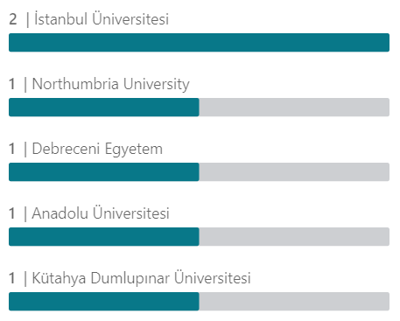

Figure 2.2 Educational Level of Invaco Personnels

Regarding the achieving business strategies, it has been planned by the company to build more departments and include more personnels to its organizational structure for the purpose of producing more effective projects.

|  |  |
| --- | --- |
| **TITLE** | **Number Of Employee** |
| HUMAN RESOURCES DEPARTMENT | 1 |
| MARKETING DEPARTMENT | 1 |
| INFORMATION TECHNOLOGY DEPARTMENT | 3 |

Table 2.1 Departmental Distribution of Employees

The Human Resources Department is responsible for many processes of personnel related activities such as recruitment processes, job termination processes, documentation, generating activities to increase the personnel motivation during the year.

The personnel in Marketing Department has bacholer degree on economic department. The functions of Marketing Department are to make detailed market researches, to explain what Invaco Teknoloji A.Ş. do in the industry and how they can help the customers and what are Invaco has been following the 4P Marketing Strategy in order to gain the customer satisfaction and become successful in the market. Pricing, Promotion, Place, Product. In Invaco’s case, place is Internet and digital environment while product is the services and softwares provided. The department are responsible for sales operations and sales solutions, for achieving customers through different channels such as social media, online fairs, and many more in order to meet the customer demands.

Regarding to the Information Technology Department, it can be defined as the heart of the company due to it is giving services digital technologies industry. There 3 personnels in this department who are developing all the digital services such as writing codes for softwares needed by clients, supporting companies with specialized consulting in specific fields, generating mobile applications and conducting R&D activities.

### Organizational Chart of The Company

In the previous section, the knowledge about departmental structure, the responsibilities of departments, the position of departments in the business, number of employees working in each departments has been shared. According to the observations gained during the internships, an organizational chart have been prepared as seen in Figure 2.2. However, in entire internship communication has been made with only Yunus Onur Atasoy and Emre Çetinkaya, and entire internship has been realized online. Therefore, none of knowedge about other personnels have been reached and never communicated with those who work in such as Human Resources Department and Marketing Department.



Figure 2.3 Organizational Chart of INVACO

# WORK EXPERIENCE

In the scope of CIU regulations 30-day compulsory internship, the research for an appropriate company to realize the internship started. After a while, thanks to one of academicians in Cyprus International University, Faculty Of Engineering, Computer & Information Systems Engineering Department, Invaco Teknoloji A.Ş. had been discovered and chosen for internship.

During the internship, Yunus Onur Atasoy and Eren Çetinkaya, IT personnels of Invaco Teknoloji A.Ş., have been mostly communicated with. While supporting the projects, Android Studio and Visual Studio Code for Phyton have been chosen.

In this chapter, the work experience during internship is explained under 3 category; Problem Definition, Work Done and Limitations & Experiences Gained.

## Problem Definition

As explained in previous chapters, the internship has been realized in order to experience the application of knowledge on the profession on site, and to learn the methods and studies for solving programming problems, to be able to have the personnel criteria that digitized companies in the sector are looking for.

The Information Technology Department is the section that communicates with client company, understands their problems, gets to know the client company technology infrastructure closer, understands client company’s business process, brings the most appropriate solutions to client company’s technologic and digital needs, writes the proper codes and create demanding software systems or applications, gives other related services such as Cloud Based Services. The internship process has been full of tasks and projects undertaken at the Information Technology Department. As mentioned at the beginning of paper, the entire internship has taken place in online environment due to COVID-19 pandemic. It did not cause any problem, thanks to digitalization of the world.

As a beginning for the internship, the meeting with Yunus Onur Atasoy who is a software engineer and has been the supervisor for my internship. All the tasks and projects prepared by myself and delivered to the company were controlled and tracked via Trello. Before beginning the projects, the first step was to recognize and discover the software languages and other technologies being used within the company. Secondly, Phyton Software Language were searched and many arcticles have been read to accomplish the 1st Project. As a third step, Java Programming Lanuage and Twilio Library which are used by the company was examined in detail to complete the 2nd Project, by the reason of that Information Technology Department especially demanded the use of Twilio Library. As last step, projects have been finished and delivered on time to the supervisor. There has been few problems faced during internship such as an error caused by an old version of videoview element given by supervisor. The reason of use of Phyton as programming language is that the company generally use Phyton in their businesses and recommended Phyton to me while progressing the First Project. Besides, considering large corporations, they mostly prefer Phyton as their basic programming language due to ease of use, flexibility, adaptability, wide-scale libraries access. Today, many of business, consulting firms, software engineers, business analysts focus on Phyton because there has been a wide range of sectors which Phyton has bring solutions. For instance, creating Web applications, face and voice recognization, traffic jam problems, entire process from unstructured data to meaningful information. It is a well-known fact that having improved Phyton skills is quite necessary for deep learning and machine learning.

In order to demonstrate how and in which way the tasks and the projects have been generated during the internship, the softwares, tools, computer programs and other technologies will be explained briefly in following sections.

### Programming Languages

As previously mentioned, there were 2 projects expected to be accomplished until the end of the internship. For the first project, it was asked to use Phyton programming Language. Phyton is general-purpose coding or programming language at high level productivity and it is commonly preferred in machine learning, Fintech, data science, scientific computing and general Web development.

In order for 2nd Project, Java was used as programming language due to it is an Android application. Kotlin Programming Language could also be used in the process of generating Android application for the 2nd Project, however the supervisor especially gave instruction to choose Java programming language. Java is a programming language and operating platform. It is now ubiquitous from laptops to storage centers, from play consoles to scientific super computers, from mobile phones to Internet.[4]

### 3.1.2 Technologic Tools

During the process of generating 2nd Project, many tools have been benefitted from. One of these tools is Android Studio[5] which was used at a critical point. Android Studio provides a unified environment where you can build apps for Android devices such as phones, tablets, TVs. Structured code modules allow you to divide your project into units of functionality that you can independently build, test, and debug.

In the upcoming parts of 2nd Project, Sonarlint Application has been used. It is an Eclipse plugin that provides on-the-fly feedback to developers on new bugs an quality issues injected into Java, JavaScript and PHP code.[6]

Regarding to the use of programming languages and varied technologic tools, internship has developed my current knowledge beyond that ever expected. Besides, the supervisor, Yunus Onur Atasoy, mostly has been leading during the projects, asked for many revises, and sahared his experiences and recommended many more easy ways about how to build Android applications, correct errors and how to manage a project. As planned before the internship, the knowledge received through school had been converted into practices and experiences during the internship.

## Work Done

**In the Problem Definition part, it was explained that what tasks are given and which projects has been prepared or what kind of programming languages and technologic tools have been used during the internship. In this part, it will be presented in detail that what has been done with previously explained tools and programming languages to accomplish the tasks and projects.**

The daily report of entire internship has been summarized and together with all data coming from this daily reports, Table 3.2 was created. It demonstrates how the aforementioned 2 projects have been managed and given tasks were accomplished step-by-step.

|  |  |
| --- | --- |
| **DAYS** | **SUMMARY OF DAILY REPORTS** |
| Day 1 | Meeting with Yunus Onur Atasoy who has been IT Engineer and the supervisor during internship |
|  | I have been tasked with 2 projects by engineer in IT department. |
|  | 1st Project: An application that assigns mouse functions to the joystick and game controller via Python |
|  | 2nd Project: An application that takes video images on the Android platform and broadcasts it on the screen |
| Day 2 | I have done researches and reading about Phyton. |
| Day 3 | I have continued on Phyton researches. |
| Day 4 | I have delivered the 1st Project. |
| Day 5 | I have started researches for 2nd Project. Regarding to 2nd Project, I was asked to generate the application by using the Twilio Library, which Invaco Teknoloji A.Ş. benefits from. |
| Day 6 | I have began the researches and pre-studies about Java for 2nd Project. The IT Department also provided informing documents about Java. |
| Day 7 | I have continued on researches and pre-studies about Java for 2nd Project. |
| Day 8 | I have continued on researches and pre-studies about Java for 2nd Project. |
| Day 9 | I have finished all the informing documents given by IT department and researches about Java. I have began to focus on Twilio Library provided by IT engineer. |
| Day 10 | I have continued investigation on Twilio Library. |
| Day 11 | I have continued investigation on Twilio Library. |
| Day 12 | I have started schematic design part of the application for 2nd Project after Twilio Library researches was done. |
| Day 13 | IT Engineer asked for 3 button to add and to design icon for each of three buttons in the application. (Like, Dislike, Circle) |
| Day 14 | I have accomplished the button designs via Photoshop Program. |
| Day 15 | I have delivered the button designs. After IT engineer viewed the designs, I was asked for a revise. The design studies has restarted. |
| Day 16 | I have delivered the revised button designs. After second viewing, designs has been approved. However, IT engineer asked the designs in the form of XML, not PNG. |
| Day 17 | I have began the researches for conversion of PNG form to XML form. |
| Day 18 | I have converted the button design icons to XML with Vector Asset via Android Studio. |
| Day 19 | I have adapted the icons in XML versions into application for 2nd Project. |
| Day 20 | I have delivered the report of new version of application. I was asked to upload the Sonarlint Application onto Android Studio. I have learned that it easier to determine the errors with this application. |
| Day 21 | I have controlled that the methods and variables which I had used with Sonarlint, and determined the errors. (Error: Since the videoview element version the engineer gave me is old, I could not receive the view. This videoview element is a tool of Twilio Library.) |
| Day 22 | After discovering the error, I have had the new version in Twilio's own documentation. |
| Day 23 | I have delivered the application report and I was asked to add functions onto buttons. IT engineer wanted the icons appear on the screen when clicked. |
| Day 24 | I have started to search about button click events in Android. |
| Day 25 | I have found similar use of button click events from Stackoverflow. (https://stackoverflow.com/questions/20156733/how-to-add-button-click-event-in-android-studio) |
| Day 26 | I have added functions to buttons. I have aimed to add the image which appears when use the button as a gif and made a research about it. (https://stackoverflow.com/questions/63363325/i-want-to-change-the-gifimageview-location-on-android) |
| Day 27 | I have added gif and delivered application report, but I was asked to do another timer rather than gif. In other words, IT engineer wanted the the image to appear for 5 seconds when clicked the button, and then disappear. |
| Day 28 | I have added timer feature to button click event, and I have delivered the report to IT engineer. |
| Day 29 | Instead of appearing on the screen when the app button is clicked, they wanted it to appear where the user touched it. |
| Day 30 | I have started researching about this new task. (https://stackoverflow.com/questions/22618870/how-to-move-character-with-touch-on-android https://stackoverflow.com/questions/63491064/how-can-i-have-more-than-one-imageview-on-the-screen-at-the-same-time-when-i-cli) |
| Day 31 | I have added the touch event and I have delivered the application report. I also was asked to add new features: |
|  | They wanted the image that appears when touched to be passed with the buttons. I have started researching. |
| Day 32 | With the SetOnClickListener (Ready method) and SetupButtons (I wrote this method) methods, I changed the background of the image on the screen and added the image I took from the camera of mobile phone to the application. Now there is the image taken from the camera in the background of the application screen and when you touch the screen, an image of 100x100px is printed. You can change this view using the buttons. |
| Day 33 | I was asked to add a new feature; creating 4th button and adding the function to transfer between back and front cameras. I have started researching. |
| Day 34 | I wrote the SetCameraChange method. First, I assigned a default camera at application opening. With the SetCameraChange method, I determined which camera it was on with ‘if’ query. According to the result of the query, I changed my variable 'CameraCapturer' which sends images to the camera. And I sent the application report. |
| Day 35 | I added Google Firebase's Crashlytics feature. Then we realized a user test with an IT engineer. I made a clean copy of the application. I wrote comments about what the methods do. Finally, I have delivered the 2nd Project. |

**Table 3.1 Summary of Daily Report of Internships**

### Project 1 : An application that assigns mouse functions to the joystick and game controller via Python

It is a project about an application that basicly assigning the mouse functions to the joystick and game controller. In other words, The application has been built via Phyton Programming Language and to run on desktop computers and Windows operating system. Here is a template demonstrating what exactly was performed in order to create the application as in Figure 3.1.

### Project 2 : An application that takes video images on the Android platform and broadcasts it on the screen

The 2nd Project has entailed much more intensive attention than the first project. The time needed to finish was quite longer, the effort needed to continue the process accurately was more. The objective of this project is to create an application that takes video images on the Android platform and broadcasts it on the screen. In other words, the application provides a passage or a changeover between front camera to back camera. Here is an illustrative visuals demosntrating what exactly was performed to create this application as in Figure 3.2 and Figure 3.3.

## Limitations and Experience Gained

Within 30-day internship, there has been few malfunctions as well as great experiences. In this section, the problems and missings faced during realizing projects and tasks explained earlier and how the process could be enhanced will be analysed in detail.

### Problems Faced

During the preparation process of 2nd Project, naturally, there were some problems regarding the inharmoniousness between Video Texture View and XML File. The aim was to play the local video with Video Texture View, however when added Video Texture View to the XML File, a failure has become apparent. The problem was shared over stackoverflow.com in order to find a solution from someone who experience similar issue. Figure 3.4 displays all the details of problem faced.

However, after searching the reason of problem for a while, it has been found out that the method used at first by myself was old version of Videoview elements and no longer valid. Since the videoview element version the engineer gave me is old, therefore view could not reached. This videoview element is a tool of Twilio Library. After realizing the originated reason of the error, the supervisor has given an advise for a new method that will not create a problem. Later on, the project has been progressed with the use of new method advised by supervisor. The method has been controlled over Sonarlint in order to determine the errors if there is any. Finally there was no found failure and projects has continued to progress. Discovering the problem and later reorganizing and straighten the inharmoniousness by new recommended method has taken time. The solution of this project has been generated as seen in Figure3.3 MultiTouch Control.

### What was missing/lacking?

The most bone-deep failure to fulfilment about the company is that there were no qualified software engineer at high-level in Information Technology Department. This one of the disadvantages of realizing internship at a start-up business. While preparing the applications, the software engineer in the department have mostly come with the response of that they do not know how to fix it when a problem or a failure has been appeared. None of advantages of working for large corporations have been appeared. This circumstance have made the stages of the management of given projects crawled and moved further so slowly. The reason is that all the failures had to be searched and solved by myself and my own skills.

From a different point of view, insufficiency of software engineer in Information Technology Department forced my technical skills to be improved in a very short term.

### How could you have done your work better?

More time in internship would make the experience gaining more efficient. Restricted time especially for those who works in information technology sector do not enable to have full knowledge on site. However, limited time also pushes individuals to accomplish the tasks more effective due to that they have to produce more output (information) with limited resources (time).

### How could you have gained more experience?

Taking parts in different projects and serving to companies from different industries would lead my technical skills to be developed. By this way, having a comprehensive knowledge of all kind of usage of technologies and tools in different sectors will be likely and easily. However, choosing a start-up business in order to do internship became an obstacle to experience the use of technologies and tool in large corporations and in varied industries. If a corporation would be chosen, More experience could be gained and more knowledge could be reached beyond now.

### What did you learn in summary?

During the internship Phyton programming language, Twilio Library and Java programming language have been searched and gained a large scale of information about this technologic tools. How to conduct a project management stage-by-stage has been learned in detail. What have learned at school theorytically has been transformed into practical experiences.

### How will this experience help you in the future?

As mentioned before, limited time occasionally affects people to be more effective. Hence 30-day internship helped to improve my practical skills in restricted time. Certainly, it will be quite essential in today’s competitive private business environment. The more you produce within the shorter time is the most wanted strength by employees.

Moreover, gaining a large scale of Phyton, Java and also Twilio Library knowledge during the preparing process will help to focus on artificial intelligence, and how to be more creative with the channels of these programming languages and technologic tools.

Besides, doing internship in a start-up business has pushed my skills to be improved due to that the only person who can bring solutions to the problems faced was myself. Being an expert in the field of digital technology is not enough to be successful. Due to that business are involving people who works together, social relations and disciplines are also essential at this point. Learning how to organize a discipline of work and how to manage a project in a systematic framework and taking responsibilities will make it easier to progress in future career line.

# CONCLUSION

To sum up 30-day compulsory internship realized at Invaco Teknoloji, in general, there has been many advantages as well as disadvantages. At the beginning, this company has been chosen due to it is a start-up business, and facing with all failures of a start-up business, would improve my analytic problem-solving skills. When you do not have any chance to learn what you need from someone who is an expert in the field, you must figure out what is needed to be done in order to solve the problem by yourself and continue the process. This was the one of the biggest advantages of the internship.

Regarding to the work environment, the supervisor, Yunus Onur Atasoy, and other software engineer, Emre Çetinkaya, was kind and helpful to the problems I have faced as they can. In Information Technology Department, sometimes the problems are thought, discussed, solutions are brought, ideas are argued with all positive and negative sides but it was not as efficient as in my expectations before the internship. This situation is caused by there are not enough personnels in the company and exiting employers do not have enough qualifications in order to answer all my questions. Certainly, the circumstance would be more different if a large corporation with more software engineers at high-level qualifications. Moreover, it was quite hard to reach the company by any channel and receive responses to my questions for preparing internship report after the internship. As mentioned in earlier parts, the internship was realized in digital environment, and it is likelihood that these problems originated from not working face-to-face.

From the technical information view of point, the best and the most important advantage of the internship is that discovering Phyton, Java and Twilio Library by own myself broaden my horizons at technical field. When a chance appear to work with artificial intelligence in future, Phyton and Java knowledge and skills will be very important in order to be successful.

In general, it has been a full of hard-worked and enormously productive of 30-days internship for me beyond the expectations before the internship. Within just a month, finishing two projects involving creating application and readjusting the tasks due to the supervisor revise demands have been extremely intense. These hard-worked 30 days will have a positively great impact on my future career.

# REFERENCES

[1] Invaco Teknoloji A.Ş. (2017) Biz Kimiz. Available: http://www.invaco.net

[2] Serra Yılmaz, Nihan Türen, Damla Ertürk, Tuğba Tiryaki, Ebru Dicle, Yasemin E. Avcı, Merve Uzunosman, Bahar Karayüksel, Hakan Göl, Mehmet Adem Soran Bilge Sarı, Sezai Danacı “Genel Değerlendirme” in Türkiye’deki Dijital Değişime CEO Bakışı TUSIAD & SAMSUNG & DELOITTE & GFK, 2016, pp.40

[3] Google Developer. (2020, 08 25). Android Studio. Available: https://developer.android.com/studio/features

[4] ORACLE. Java Yardım Merkezi. Available: https://java.com/tr/download/help/whatis_java.html

[5] Günay, İ. (2016, 12 04). Sonar İle Kod Kalitesini Artırın. Available: http://ilkaygunel.com/blog/2016/sonar-plugin/

[6] Redhat. (2020). What are cloud applications?. Available: https://www.redhat.com/en/topics/cloud-native-apps/what-are-cloud-applications

# APPENDIX

The First Project Coding shown in Figure 3.1 Usage of Phyton in Application Building Process

#Python'un windows sistemlerini kontrol edebilmesi için windows DLL'leri ile beraber çalışan kütuphanesi

#Bu kütuphaneyi yüklemek için "python -m pip install pypiwin32" komutu gerekiyor

import win32api,win32con

#time kütuphanesi ile mouse'un çalışma hızını ayarlayacağız

import time

#os kütuphanesi ile pygame'de ihtiyaç duymadığımız ekran çıktılarını kapatıyoruz

import os

os.environ['PYGAME_HIDE_SUPPORT_PROMPT'] = "hide"

#pygame aslında python ile oyun yazabilmek adına geliştirilmiş bir kütuphanedir. Biz yalnızca bu kütuphaneyi joystick girdilerini almak için kullanacağız

#Ayrı kurulumu yapılması gerekiyor kurulumu için "python -m pip install pygame" komutunu girmek yeterli

import pygame

#pygame'i başlatıyoruz

pygame.init()

#pygame.joystick modülünden bilgisayara bağlı bir joystick var mı onu kontrol ediyoruz

#Herhangi bağlı joystick yoksa "pygame.joystick.get_count()" komutu int(0) değerini döndürür

while pygame.joystick.get_count()<1:

    print("Bağlı joystick bulunamadı!",end="\r")

#Bağlı joystick algılandıktan sonra joystick girdilerini almak için kodu başlatıyoruz

pygame.joystick.init()

#"hiz" değerini time.sleep() fonksiyonu içerisinde kullanacağız time.sleep(1) fonksiyonu işlemi 1 saniye durdurur o yüzden 1 yerine "1/hiz" yazacağız

#hiz ne kadar artarsa mouse hızı da o kadar artar

hiz = 1700

#scroll_hiz değişkenini scroll'a ait hızı belirlemede kullanacğız

scroll_hiz = 3

#scroll için tuş yapılandırması. Scroll'u yukarı ve aşağı kullanacağımız için iki değer belirledik

#1,2 değerleri joystick'teki B ve A değerlerine karşılık gelmektedir. Farklı tuşlar için farklı değerler girilmeli

#genellikler tuş değerleri aynıdır dünya genelinde. İnternetten kısa bir araştırmayla bu değerleri bulabilirsiniz

yukari = 1

asagi = 2

#Bütün hazırlıklar tamamlandığı ve sistem çalışmaya hazır olduğu için ekrana "Başlatıldı!" yazıyoruz.

print("Başlatıldı!")

#Sonsuz döngü içerisinde programı başlatıyoruz.

while 1:

    #ilk başta gelen klavye girdilerine bakıyoruz. Buradaki 12 değeri çıkma komutudur. Klavyeden Ctrl+C kombinasyonuna basarsanız bu 12 komutunu gönderir

    for event in pygame.event.get():

        if event.type == 12:

            exit()

    #Bazı oyun kollarında sistemde 2 tane kol bağlanmış gibi gözükebiliyor o yüzden biz bağlı joystick sayısı kadar çalışacak bir döngü içerisine giriyoruz

    for i in range(pygame.joystick.get_count()):

        #i değeri bir integer'dır. Alttaki kodda i değerine göre bağlı joystick'i seçiyoruz.

        joystick = pygame.joystick.Joystick(i)

        #joystick'in adını \r kaçış karakteriyle ekrana bastırıyoruz. Böylece her seferinde yeni bir satır değil eski satırın üstüne yazmış oluyoruz.

        print(joystick.get_name()," bağlı ve çalışıyor.",end="\r")

        #üstteki kodda seçtiğimiz joystick'i başlatıyoruz

        joystick.init()

        #joystick'in sol çubuğunun x değerini alıyoruz. x değeri -1,1 arasında ondalıklı bir sayı döndürür

        axis_Lx = joystick.get_axis(0)

        #çubuk için bir sınır değer belirliyoruz. bu sınır değer 0.5 Değer yükseltilirse çubuğu hareket ettirmemiz gereken mesafe artar

        if axis_Lx >.5 or axis_Lx <-.5:

            #win32api yardımıyla cursor'un anlık pozisyonunu alıyoruz (x,y) şeklinde bir tuple döndürüyor

            curPos = win32api.GetCursorPos()

            #win32api yardımıyla cursor'un pozisyonunu belirliyoruz. win32api.SetCursorPos(x,y)

            #Şu anda x ekseni ile çalıştığımız için y değerini direkt giriyoruz

            #x eksenini de çubuğun hareket yerine göre 1 arttırıyoruz ya da 1 çıkartıyoruz ve değerleri giriyoruz.

            #çubuk sola kaymışsa axis_Lx değerimiz (-1,0) aralığında alıyor.

            win32api.SetCursorPos((int(curPos[0]+ (1 if axis_Lx>0 else -1)),curPos[1]))

            #programı 1/hiz kadar uyutuyoruz böylece mouse kullanımını daha kolay hale getiriyoruz.

            time.sleep(1/hiz)

        #joystick'in sol çubuğunun y değerini alıyoruz. y değeri -1,1 arasında ondalıklı bir sayı döndürür

        axis_Ly = joystick.get_axis(1)*100

        #çubuk için bir sınır değer belirliyoruz. bu sınır değer 0.5 Değer yükseltilirse çubuğu hareket ettirmemiz gereken mesafe artar

        if axis_Ly >50 or axis_Ly <-50:

            #win32api yardımıyla cursor'un anlık pozisyonunu alıyoruz (x,y) şeklinde bir tuple döndürüyor

            curPos = win32api.GetCursorPos()

            #win32api yardımıyla cursor'un pozisyonunu belirliyoruz. win32api.SetCursorPos(x,y)

            #Şu anda y ekseni ile çalıştığımız için x değerini direkt giriyoruz

            #y eksenini de çubuğun hareket yerine göre 1 arttırıyoruz ya da 1 çıkartıyoruz ve değerleri giriyoruz.

            #çubuk yukarı kaymışsa axis_Ly değerimiz (0,1) aralığında alıyor.

            win32api.SetCursorPos((curPos[0],int(curPos[1]+ (1 if axis_Ly>0 else -1))))

            #programı 1/hiz kadar uyutuyoruz böylece mouse kullanımını daha kolay hale getiriyoruz.

            time.sleep(1/hiz)

        #Scroll için belirlediğmiz tuşun basılıp basılmadığını kontrol ediyoruz

        #joystick.get_button(int) komutu değeri verilen tuşun basılıp basılmadığı ile alakalı olarak Bool döndürür

        if joystick.get_button(yukari):

            #win32api kütuphanesinin mouse_event fonksiyonuyla farenin yapacağı işi anlatıyoruz

            #win32con.MOUSEEVENTF_WHEEL fare'de scroll'un çalışacağını belirtiyor, ardından fare'nin anlık pozisyonunu giriyoruz x,y olarak

            #4. parametre olarak da scroll_hiz değerini vererek ne kadar hızlı kaydırması gerektiğini gösteriyoruz

            #5. parametre varsayılan olarak 0 olmalı

            win32api.mouse_event(win32con.MOUSEEVENTF_WHEEL, win32api.GetCursorPos()[0], win32api.GetCursorPos()[1],scroll_hiz , 0)

        #Scroll için belirlediğmiz tuşun basılıp basılmadığını kontrol ediyoruz

        #joystick.get_button(int) komutu değeri verilen tuşun basılıp basılmadığı ile alakalı olarak Bool döndürür

        if joystick.get_button(asagi):

            #win32api kütuphanesinin mouse_event fonksiyonuyla farenin yapacağı işi anlatıyoruz

            #win32con.MOUSEEVENTF_WHEEL fare'de scroll'un çalışacağını belirtiyor, ardından fare'nin anlık pozisyonunu giriyoruz x,y olarak

            #4. parametre olarak da scroll_hiz değerini vererek ne kadar hızlı kaydırması gerektiğini gösteriyoruz

            #5. parametre varsayılan olarak 0 olmalı

            win32api.mouse_event(win32con.MOUSEEVENTF_WHEEL, win32api.GetCursorPos()[0], win32api.GetCursorPos()[1],-scroll_hiz , 0)

Figure 3.1 Usage of Phyton in Application Building Process

The Second Project Main Activity Coding shown in Figure 3.2 Main Activity

|  |
| --- |
| public class MainActivity extends AppCompatActivity { |
|  |  |
|  | private static final int CAMERA_PERMISSION_REQUEST_CODE = 100; |
|  |  |
|  | private VideoView localVideoView; |
|  | private ImageView snapshotImageView; |
|  |  |
|  | private SnapshotVideoRenderer snapshotVideoRenderer; |
|  | private LocalVideoTrack localVideoTrack; |
|  | ImageButton cameraChange; |
|  | CameraSource cameraCapturer; |
|  |  |
|  |  |
|  | ImageButton circleButton, likeButton, dislikeButton; |
|  |  |
|  | VideoTextureView videoTextureView; |
|  |  |
|  | ImageView imageView; |
|  |  |
|  |  |
|  | int selectedImage = R.drawable.ic_yuvarlak_ici_bos; |
|  | // imageviewın default daki görüntüsü |
|  |  |
|  |  |
|  | @SuppressLint("ClickableViewAccessibility") |
|  | @Override |
|  | protected void onCreate(Bundle savedInstanceState) { |
|  | super.onCreate(savedInstanceState); |
|  | setContentView(R.layout.activity_main); |
|  |  |
|  | imageView = new ImageView(this); |
|  | imageView.setImageResource(R.drawable.ic_yuvarlak_ici_bos); |
|  | localVideoView = findViewById(R.id.local_video); |
|  |  |
|  | cameraCapturer = FRONT_CAMERA; |
|  | // Cameranın çalıştaki default olan seçeneği |
|  |  |
|  |  |
|  | final FrameLayout frameLayout = findViewById(R.id.frame_layout1); |
|  |  |
|  |  |
|  | circleButton = findViewById(R.id.circle); |
|  | dislikeButton = findViewById(R.id.dislike); |
|  | likeButton = findViewById(R.id.like); |
|  | cameraChange = findViewById(R.id.cameraChange); |
|  | //Kamera izinlerini kontrol edin. Android M'de gerekli. |
|  | if (!checkPermissionForCamera()) |
|  | { |
|  | requestPermissionForCamera(); |
|  | } else { |
|  | addVideo(); |
|  | } |
|  | // if de camera izinlerini almış mı alınmamış mı onu kontol ediyor |
|  | // alınmışsa direk elseyle addVideo metoduyla camera görüntüsünü bastıyor |
|  |  |
|  |  |
|  | cameraChange.setOnClickListener(new View.OnClickListener() { |
|  | @Override |
|  | public void onClick(View view) { |
|  |  |
|  | setCameraChange(); |
|  | // Cameralar arasında geçiş için yaptığım |
|  | // butonun metodu |
|  |  |
|  | } |
|  | }); |
|  |  |
|  | // çoklu dokunma için MultiTouchControl ten nesne oluşturdum |
|  | MultiTouchControl multiTouchControl = new MultiTouchControl(frameLayout, new MultiTouchControl.ComponentView() |
|  | { |
|  |  |
|  | @Override |
|  | public View onCreateComponent() { |
|  |  |
|  | // Çoklu dokunma da oluşturulacak olan elemantin nesnesi oluştum. |
|  | // hangi katmanda gösterileceğini belirdim =>frameLayout.getContext() |
|  | ImageView image = new ImageView(frameLayout.getContext()); |
|  | image.setImageResource(selectedImage); |
|  | // selectedImage seçilen butonu iconu saklayan değişken |
|  |  |
|  | return image; |
|  | } |
|  | }); |
|  |  |
|  | multiTouchControl.startListener(); |
|  |  |
|  | // dokunma dinlemesini başlatıyor. |
|  |  |
|  | setupButtons(); |
|  |  |
|  | // setupButtons da Butonların metodlarını barındıran general metod |
|  |  |
|  | } |
|  |  |
|  | //Camera izinlerini override metodları |
|  | // izin kontrolleri yapılıyor ve ona göre ekrana camera nın görüntüsü bastırıyor |
|  | @Override |
|  | public void onRequestPermissionsResult(int requestCode, |
|  | @NonNull String[] permissions, |
|  | @NonNull int[] grantResults) { |
|  | if (requestCode == CAMERA_PERMISSION_REQUEST_CODE) { |
|  | boolean cameraPermissionGranted = true; |
|  |  |
|  | for (int grantResult : grantResults) { |
|  | cameraPermissionGranted &= grantResult == PackageManager.PERMISSION_GRANTED; |
|  | } |
|  |  |
|  | if (cameraPermissionGranted) { |
|  | addVideo(); |
|  | } else { |
|  | Toast.makeText(this, |
|  | R.string.permissions_needed, |
|  | Toast.LENGTH_LONG).show(); |
|  | } |
|  | } |
|  | } |
|  |  |
|  | // App nin açılış ekranında camera görüntüsünü release yapıyor |
|  |  |
|  | @Override |
|  | protected void onDestroy() { |
|  | localVideoTrack.removeRenderer((VideoRenderer) localVideoView); |
|  | localVideoTrack.removeRenderer(snapshotVideoRenderer); |
|  | localVideoTrack.release(); |
|  | localVideoTrack = null; |
|  | super.onDestroy(); |
|  | } |
|  |  |
|  | // Ekrana kamera görüntüsünü yansıtıyor |
|  | private void addVideo() { |
|  | localVideoTrack = LocalVideoTrack.create(this, true, new CameraCapturer(this, |
|  | cameraCapturer, null)); |
|  | snapshotVideoRenderer = new SnapshotVideoRenderer(snapshotImageView); |
|  | localVideoTrack.addRenderer((VideoRenderer) localVideoView); |
|  | localVideoTrack.addRenderer(snapshotVideoRenderer); |
|  | localVideoView.setOnClickListener(v -> { |
|  |  |
|  | }); |
|  | } |
|  |  |
|  |  |
|  | // CameraChange butona bastığınızda çalışan metod |
|  | // ve camera görüntüsünü değişmesini sağlıyor |
|  | public void setCameraChange() { |
|  | if (cameraCapturer == FRONT_CAMERA) { |
|  | Toast.makeText(MainActivity.this, "Camera Change BACK_CAMERA", Toast.LENGTH_LONG).show(); |
|  | cameraCapturer = BACK_CAMERA; |
|  | onDestroy(); |
|  | addVideo(); |
|  |  |
|  | } else if (cameraCapturer == BACK_CAMERA) { |
|  | Toast.makeText(MainActivity.this, "Camera Change FRONT_CAMERA", Toast.LENGTH_LONG).show(); |
|  | cameraCapturer = FRONT_CAMERA; |
|  | onDestroy(); |
|  | addVideo(); |
|  |  |
|  | } |
|  |  |
|  |  |
|  | } |
|  |  |
|  | // ekaranda görünen imageviewin iconlarını değişmesi sağlayan metodalar |
|  |  |
|  | private void setupButtons() { |
|  | circleButton.setOnClickListener(new View.OnClickListener() { |
|  | @Override |
|  | public void onClick(View view) { |
|  | Toast.makeText(MainActivity.this, "Circle", Toast.LENGTH_LONG).show(); |
|  | selectedImage = R.drawable.ic_yuvarlak_ici_bos; |
|  |  |
|  |  |
|  | } |
|  | }); |
|  |  |
|  | dislikeButton.setOnClickListener(new View.OnClickListener() { |
|  | @Override |
|  | public void onClick(View view) { |
|  | Toast.makeText(MainActivity.this, "Dislike", Toast.LENGTH_LONG).show(); |
|  | selectedImage = R.drawable.ic_dislike3; |
|  |  |
|  |  |
|  | } |
|  | }); |
|  | likeButton.setOnClickListener(view -> { |
|  | Toast.makeText(MainActivity.this, "Like", Toast.LENGTH_LONG).show(); |
|  |  |
|  | selectedImage = R.drawable.ic_like3; |
|  |  |
|  |  |
|  | }); |
|  | } |
|  |  |
|  | //Camera izinlerini return yapıyor |
|  | private boolean checkPermissionForCamera() { |
|  | int resultCamera = ContextCompat.checkSelfPermission(this, Manifest.permission.CAMERA); |
|  | return resultCamera == PackageManager.PERMISSION_GRANTED; |
|  | } |
|  | //Uygulamasını ilk kurulunda açılan için ekranlarını bastıyor |
|  |  |
|  | private void requestPermissionForCamera() { |
|  | ActivityCompat.requestPermissions(this, new String[]{Manifest.permission.CAMERA}, |
|  | CAMERA_PERMISSION_REQUEST_CODE); |
|  | } |
|  | } |

Figure 3.2 Main Activity

The Second Project MultiTouch Control Coding shown in Figure 3.3 MultiTouchControl

|  |
| --- |
| public class MultiTouchControl implements View.OnTouchListener { |
|  |  |
|  | private ViewGroup root; |
|  | private ComponentView componentView; |
|  | private float circleSize = 100; |
|  | private int duration = 1500; |
|  | private List<Vector3> fingerTips = new ArrayList<>(); |
|  | private boolean enabled = true; |
|  |  |
|  | public MultiTouchControl(ViewGroup root, ComponentView componentView, float circleSize, int duration) { |
|  | this.root = root; |
|  | this.componentView = componentView; |
|  | this.circleSize = circleSize; |
|  | this.duration = duration; |
|  | } |
|  |  |
|  | public MultiTouchControl(ViewGroup root, ComponentView componentView) { |
|  | this.root = root; |
|  | this.componentView = componentView; |
|  | } |
|  |  |
|  |  |
|  | // Dinlemeyi başlatıyor |
|  | public void startListener(){ |
|  | root.setOnTouchListener(this); |
|  | } |
|  |  |
|  |  |
|  | @SuppressLint("ClickableViewAccessibility") |
|  | @Override |
|  | //Parmaklarını algılanmasını sağlıyor |
|  | public boolean onTouch(View v, MotionEvent event) { |
|  | if (!enabled) |
|  | return false; |
|  | final int points = event.getPointerCount(); |
|  | int removedPoint = -1; |
|  | final int action = event.getAction() & MotionEvent.ACTION_MASK; |
|  | if (event.getAction() == MotionEvent.ACTION_MOVE) { |
|  | fingerTips.clear(); |
|  | return false; |
|  | } //Parmağın kaldırdıktan sonra konum verisi siliyor |
|  | if (action == MotionEvent.ACTION_POINTER_UP || action == MotionEvent.ACTION_UP) |
|  | removedPoint = (action & MotionEvent.ACTION_POINTER_INDEX_MASK) |
|  | >> MotionEvent.ACTION_POINTER_INDEX_SHIFT; |
|  | // Dokulan yerin koordinatlarını siliyor |
|  | fingerTips.clear(); |
|  |  |
|  | for (int i = 0; i < points; i++) { |
|  | int pointerID = event.getPointerId(i); |
|  | if (pointerID == MotionEvent.INVALID_POINTER_ID) { |
|  | continue; |
|  | } |
|  | if (removedPoint == i) { |
|  | continue; |
|  | } |
|  | fingerTips.add(new Vector3(event.getX(i), event.getY(i), pointerID)); |
|  | } |
|  | for (Vector3 fingerTip : fingerTips) { |
|  | createCircle(fingerTip.x, fingerTip.y); |
|  | } |
|  |  |
|  | return true; |
|  | } |
|  |  |
|  | // İmageview konum verisini belirliyor |
|  | //Interface de imageview oluşturuyor |
|  | private void createCircle(float x, float y) { |
|  | if (componentView != null) { |
|  | View view = componentView.onCreateComponent(); |
|  | ViewGroup.LayoutParams params = new ViewGroup.LayoutParams(ViewGroup.LayoutParams.WRAP_CONTENT, ViewGroup.LayoutParams.WRAP_CONTENT); |
|  | view.setX(x - circleSize / 2); |
|  | view.setY(y - circleSize / 2); |
|  | params.width = (int) circleSize; |
|  | params.height = (int) circleSize; |
|  | view.setLayoutParams(params); |
|  | root.addView(view); |
|  | dieAfter(view); |
|  | } |
|  | } |
|  | //dieAfter circle ları yoketmek için |
|  | private void dieAfter(final View view) { |
|  | new Handler().postDelayed(new Runnable() { |
|  | @Override |
|  | public void run() { |
|  | root.removeView(view); |
|  | } |
|  | }, duration); |
|  | } |
|  |  |
|  | // x , y ve id değerini tutuyor |
|  | static class Vector3 { |
|  | public float x, y; |
|  | public int id; |
|  |  |
|  | public Vector3(float x, float y, int id) { |
|  | this.x = x; |
|  | this.y = y; |
|  | this.id = id; |
|  | } |
|  | } |
|  |  |
|  | //MainActivity den gönderdiğin imageviewei veya ne gönderiyorsan onu almak için |
|  | interface ComponentView { |
|  | View onCreateComponent(); |
|  | } |
|  |  |
|  | public ViewGroup getRoot() { |
|  | return root; |
|  | } |
|  |  |
|  | public MultiTouchControl setRoot(ViewGroup root) { |
|  | this.root = root; |
|  | return this; |
|  | } |
|  |  |
|  | public ComponentView getComponentView() { |
|  | return componentView; |
|  | } |
|  |  |
|  | public MultiTouchControl setComponentView(ComponentView componentView) { |
|  | this.componentView = componentView; |
|  | return this; |
|  | } |
|  |  |
|  | public float getCircleSize() { |
|  | return circleSize; |
|  | } |
|  |  |
|  |  |
|  | // X |
|  | public MultiTouchControl setCircleSize(float circleSize) { |
|  | this.circleSize = circleSize; |
|  | return this; |
|  | } |
|  |  |
|  | public int getDuration() { |
|  | return duration; |
|  | } |
|  |  |
|  | public MultiTouchControl setDuration(int duration) { |
|  | this.duration = duration; |
|  | return this; |
|  | } |
|  |  |
|  | // MultiTouch Aktif olmasını sağlıyor |
|  | public MultiTouchControl setEnabled(boolean enabled) { |
|  | this.enabled = enabled; |
|  | return this; |
|  | } |
|  | } |

Figure 3.3 MultiTouchControl

The Error Faced During Second Project shown in Figure 3.4 The Failure Faced in 2nd Project on Stackoverflow.com Account

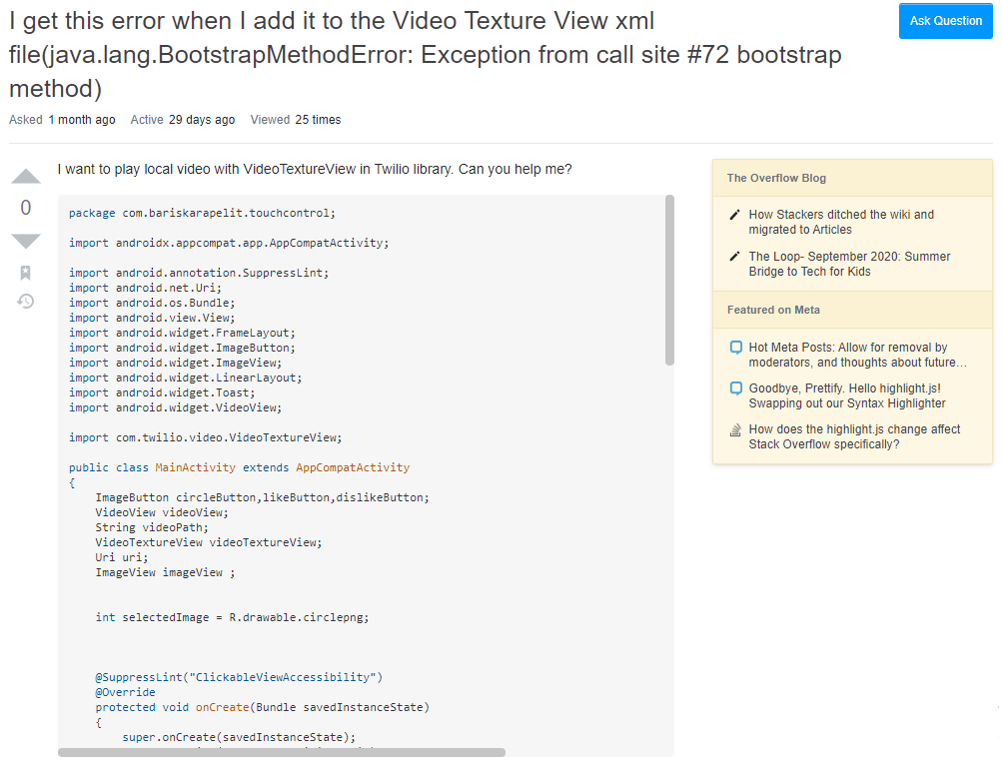

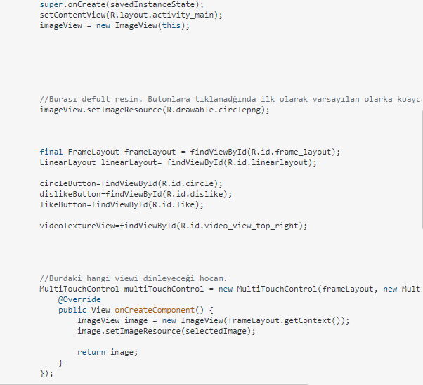

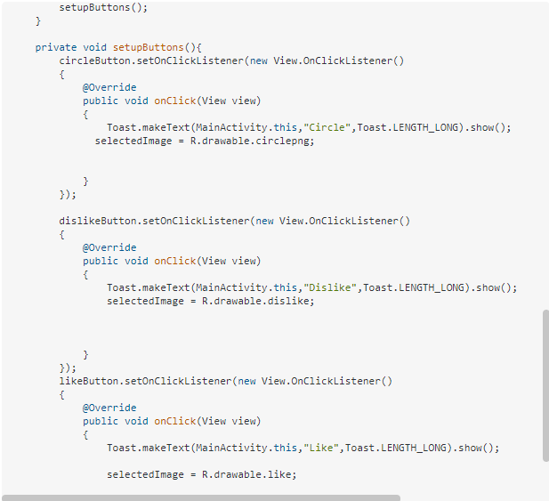

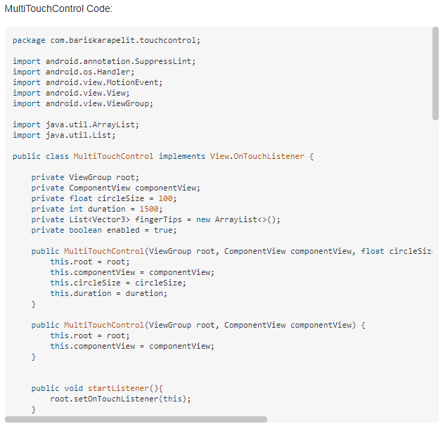

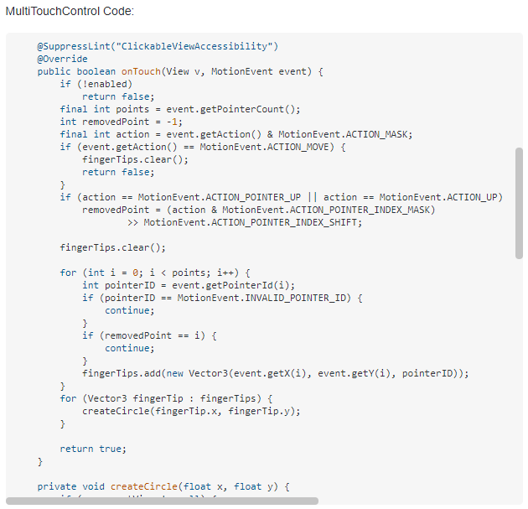

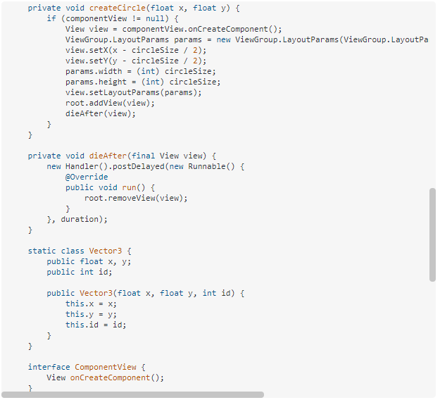

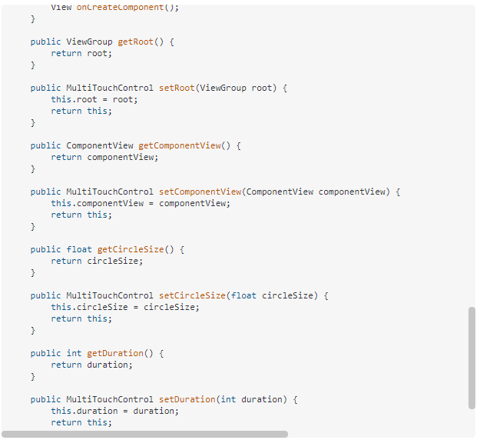

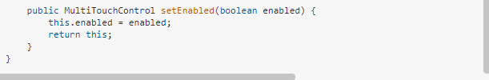

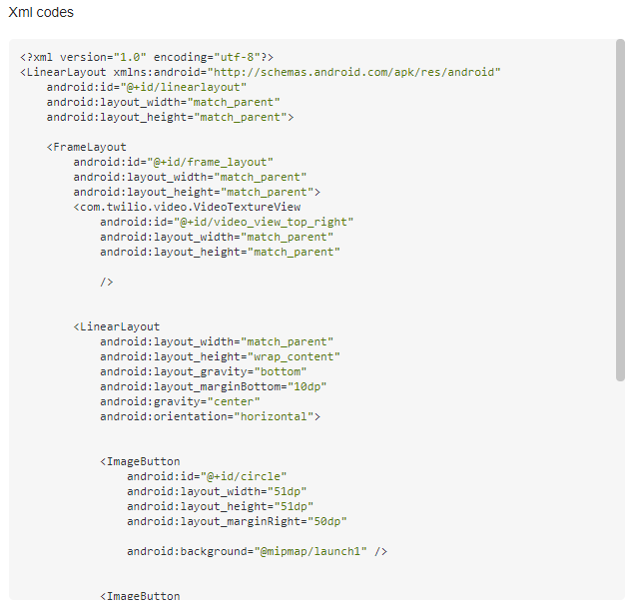

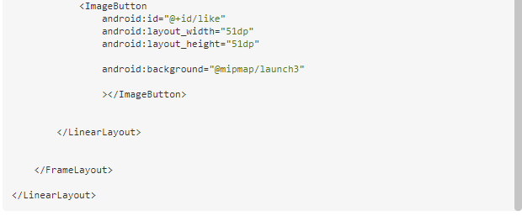

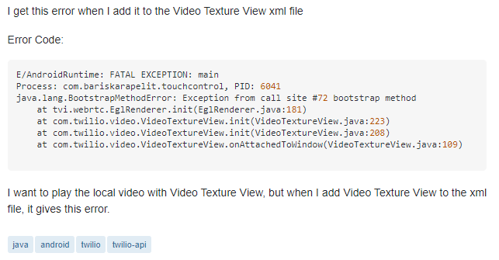

Figure 3.4 The Failure Faced in 2nd Project on Stackoverflow.com Account

1. Serra Yılmaz, Nihan Türen, Damla Ertürk, Tuğba Tiryaki, Ebru Dicle, Yasemin E. Avcı, Merve Uzunosman, Bahar Karayüksel, Hakan Göl, Mehmet Adem Soran Bilge Sarı, Sezai Danacı “Genel Değerlendirme” in Türkiye’deki Dijital Değişime CEO Bakışı TUSIAD & SAMSUNG & DELOITTE & GFK, 2016, pp.40
2. Invaco Teknoloji A.Ş. Who are we?. Available: http://www.invaco.net
3. Redhat. (2020). What are cloud applications?. Available: https://www.redhat.com/en/topics/cloud-native-apps/what-are-cloud-applications
4. ORACLE. Java Yardım Merkezi. Available: https://java.com/tr/download/help/whatis_java.html
5. Google Developer. (2020, 08 25). Android Studio. Available: https://developer.android.com/studio/features
6. Günay, İ. (2016, 12 04). Sonar İle Kod Kalitesini Artırın. Available: http://ilkaygunel.com/blog/2016/sonar-plugin/